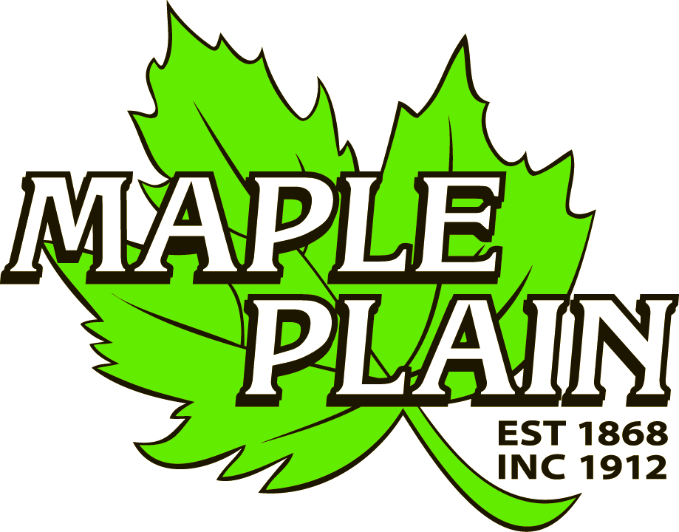
ZONING & LAND USE
City of Maple Plain
5050 Independence St
P.O. Box 97
Maple Plain, MN 55359
Office: (763) 479-0515
Fax: (763) 479-0519
APPLICATION

APPLICANT INFORMATION

Applicant Name | Company, if applicable
Address | Phone Number
City, State, Zip | Email
Are you the owner of the property? Yes. No. (If not, property owner information is required.)

Owner Name | Company, if applicable
Address | Phone Number
City, State, Zip | Email

Applicant Signature | Owner Signature
Date | Date

PROJECT INFORMATION

Site Address or Property Identification Number
Type of Request (Check all that apply.)
 | Fee | Escrow
Appeal Administration Decision | $250 | $250
Concept Plan Review | $500
Residential Application | Fee | Escrow | Commercial Application | Fee | Escrow
Conditional Use Permit  Interim Use Permit  Site Plan  Minor Subdivision  Variance  Rezoning  Text Amendment  Vacation of Property  Home Occupation | $750  $750  $750  $750  $750  $750  $750  $750  $400 | $1500  $1500  $1500  $1500  $1500  $1500  $1500  $1500  $1000 | Conditional Use Permit  Interim Use Permit  Site Plan  Minor Subdivision  Variance  Rezoning  Text Amendment  Vacation of Property  Sign Package | $1500  $1500  $1500  $1500  $1500  $1500  $1500  $1500  $500 | $3000  $3000  $3000  $3000  $3000  $3000  $3000  $3000  $3000
Residential/Commercial  Industrial/Office  Planning and Zoning Application | Fee | Escrow | Grading and Excavation  Park Fees and Signs | Fee | Escrow
Preliminary Plat  Subdivision Application  Rezoning  Comprehensive Plan Amendment  Planned Unit Development  Final Plat | $1000  $1000  $1000  $1000  $1500  $750 | $3000  $3000  $3000  $3000  $3000  $3000 | <100 Cubic Yards  >100 Cubic Yards  >1000 Cubic Yards  Right of Way Permit  Park Dedication Fee-  Residential  Park Dedication Fee-  Other  Signage Permanent  Temporary Sign | N/C  $500  $1000  $250  10% of land value of development**  10% of land value of development  $250  $25 | *See below  $1000
*Escrow or surety bond in amount of 150% of land alteration costs
** Minimum of 3,750 per unit and maximum of $8,000 per unit

Brief Project Narrative / Overview (Use additional paper if necessary. Please be thorough.)

NOTICE TO APPLICANT

The Maple Plain City Code guides and enables development activities within the City by ensuring proper and well-coordinated projects. The land use application is the mechanism that allows the City to examine proposed land uses to ensure compatibility with the City Codes, design and development standards, and the surrounding land uses and natural environments. The review is intended to ensure positive growth for the community.
All applications are reviewed individually and are evaluated based on their own merit. Each land use request has an associated checklist of required items. Applicants are encouraged to participate in the City’s pre-application workshop prior to submitting a formal land use application. The workshop is an opportunity to informally discuss the conceptual idea of the proposed project in an effort to reduce delays. Participation in the pre-application process does not provide approval, or guarantee of approval, of the project. The City shall not accept plans, drawings or other information related to the project except upon submittal of a formal application. The City reserves the right to reject an incomplete application.

APPLICATION FEE STATEMENT

All expenses pertaining to project reviews are the responsibility of the applicant. Planning review deposits and other applicable fees must be paid when submitting land use applications and accompanying materials. All fees, which are set annually by City ordinance, help cover costs incurred by the City to review the application. The City of Maple Plain often uses consulting firms to assist in the review of projects. City staff and consultant review costs are billed hourly; all other costs are billed at cost. Applicants shall be billed directly for incurred expenses upon receipt by the City. The City reserves the right to request an applicant to submit a development escrow in advance of the formal project review.
Please refer to the City’s Fee Schedule for information on planning review fees and deposits, and other applicable costs.
By signing this form, the applicant recognizes his/her responsibility for any and all fees associated with the land use application from project review through to construction and release of financial guarantees for an approved project. All fees associated with a project that is denied or withdrawn remain the sole responsibility of the applicant and shall be paid upon receipt of invoice.

I hereby understand the fee statement and responsibilities associated with this land use application:

Applicant Signature | Owner Signature
Date | Date

REVIEW REQUIREMENTS

Minnesota State Statute 15.99 requires local governments to review an application within 15 business days of its submission to determine if an application is complete and/or if additional information is required to complete the review. Once complete, a formal 60-day review period begins. The City has the ability to extend the review period an additional 60 days, if necessary, due to insufficient information or scheduling difficulties.

Please review the corresponding checklist that goes with the request as all materials are required unless waived by the City. All applications must be received by the deadline(s) attached hereto. Failure to submit by the date shown may result in a delay of the review by the Planning Commission and City Council.

DEADLINES
Planning Commission meetings are held on the first Thursday of the month at 6:00 P.M.
All applications are due 30 days prior to meeting.

OFFICE USE ONLY

Application Type | Review Deadline
15 Business Days: .

60 Day Review: .

120 Day Review: .

Fees Collected | Received by
Application Fee Collected: $ .  Escrow: $ .  Total Receipt: $ . | Name: .  Signature: .  Date: .
Receipt | Application Complete
Receipt Number(s)  . | Are there any missing materials?  Yes. No.  If yes, was the application accepted?  Yes. No.

City of Maple Plain
5050 Independence St
P.O. Box 97
Maple Plain, MN 55359
Office: (763) 479-0515
Fax: (763) 479-0519
SITE PLAN
CHECKLIST & PROCEDURE

APPLICATION REQUIREMENTS

The following materials are required in order for each application to receive consideration. The City reserves to waive certain requirements. An application that is missing materials may not be accepted.

Completed Land Use Application and pay all applicable fees.
All materials as required by City Zoning Code regarding Site Plans.
Certified survey of property (8 full size, 10 reduced) plus CAD and PDF electronic files.
Written narrative of outlining project and purpose of request.
Wetland report by Certified Wetland Specialist.

Scaled site plan showing dimensions & distances  Existing & proposed property conditions (page 2)  Four-sided architectural plans and elevations  Specifications for exterior finishes  Grading, erosion control & drainage plans (page 2)  Location of fire suppression, if applicable  Soil borings, if applicable | Parking plan  Lighting plan  Landscape plan  Utility plan  Tree Preservation plan  Signage plan  Storage & waste enclosure

APPROVALS & PERMITS

Project applications may require review and comment from the following agencies. Applicants should allow for enough time for agency review. The City encourages applicants to contact each state and county agency and the appropriate watershed district prior to submitting formal application to understand agency requirements.

City of Maple Plain  Hennepin County  MN Department of Transportation | MN Pollution Control Agency (NPDES)  Minnehaha Creek Watershed District  Pioneer-Sarah Creek Watershed Commission
Upon completion of the formal review period, the following permits may be required for an approved project. The City, county, state and other jurisdictional agencies each have a review period for all permit requests.

Building Permit  Demolition Permit  Excavation & Grading Permit  Right of Way Permit  Sewer Availability Charges (SAC)  Water Availability Charge (WAC)  Sign Permit | Hennepin County Right of Way Permit  MnDOT Right of Way Permit  Minnehaha Creek Watershed District Permit  Pioneer-Sarah Creek Watershed Commission  MnPCA Storm Water (NPDES) Construction Permit  Wetland Conservation Act requirements

NOTICE TO APPLICANT

In order to receive consideration, the applicant must complete a number of steps.
- Meet with City staff to discuss the proposed use, whether permitted or conditional, obtain a land use application packet, and schedule a pre-application meeting.
- Assemble information outlining the request.
- Submit a completed application packet, including all materials as required by City Zoning Code related to the type of request, to City Hall by the dates noted on the Land Use Application.
- Participate in the review process by attending City staff and public meetings.
- Attend all Public Hearings, and Planning Commission and City Council meetings.

By law, the City of Maple Plain must notify adjacent property owners of proposed projects that may impact their properties. This notification is mailed to property owners within 350 feet of the project area at least 10 days prior to the public hearing. A Certified List of Property Owners will be compiled by the City of Maple Plain.

ADDITIONAL INFORMATIOIN

Drawings of Existing & Proposed Conditions should include:
- gross and net acreages of the proposed development
- location, width and name of all existing streets and highway, public property, railroad, utility rights of way, & easements within the proposed development
- location and size of existing buildings & infrastructure (water, sewer and storm sewer lines)
- wetlands, wooded areas & other natural features
- tree inventory, including trees to be removed & saved
- layout of proposed streets, rights of way and appropriate street information
- layout proposed sidewalks, trails and pedestrian ways
- location and dimension of all easements
- minimum building setback lines.

Grading & Erosion Control & Drainage Plans must show the following:
- existing & proposed topography
- existing natural features, such as trees, wetlands, ponds, swales, drainage channels, etc.
- existing and proposed storm sewer facilities
- proposed storm water improvements
- flood elevations based on a 100-year flood plain
- spot elevations & directional arrows representing drainage patterns
- wetland delineation & mitigation plan at 2:1 ratio

ACKNOWLEDGEMENT

By signing this form, the applicant hereby acknowledges the receipt of the checklist and procedure for the project to be submitted for consideration. It is the responsibility of the applicant to submit all required materials. All permit requests should be submitted in a timely manner so as not to cause project delays.

Applicant Signature | Owner Signature
Date | Date

